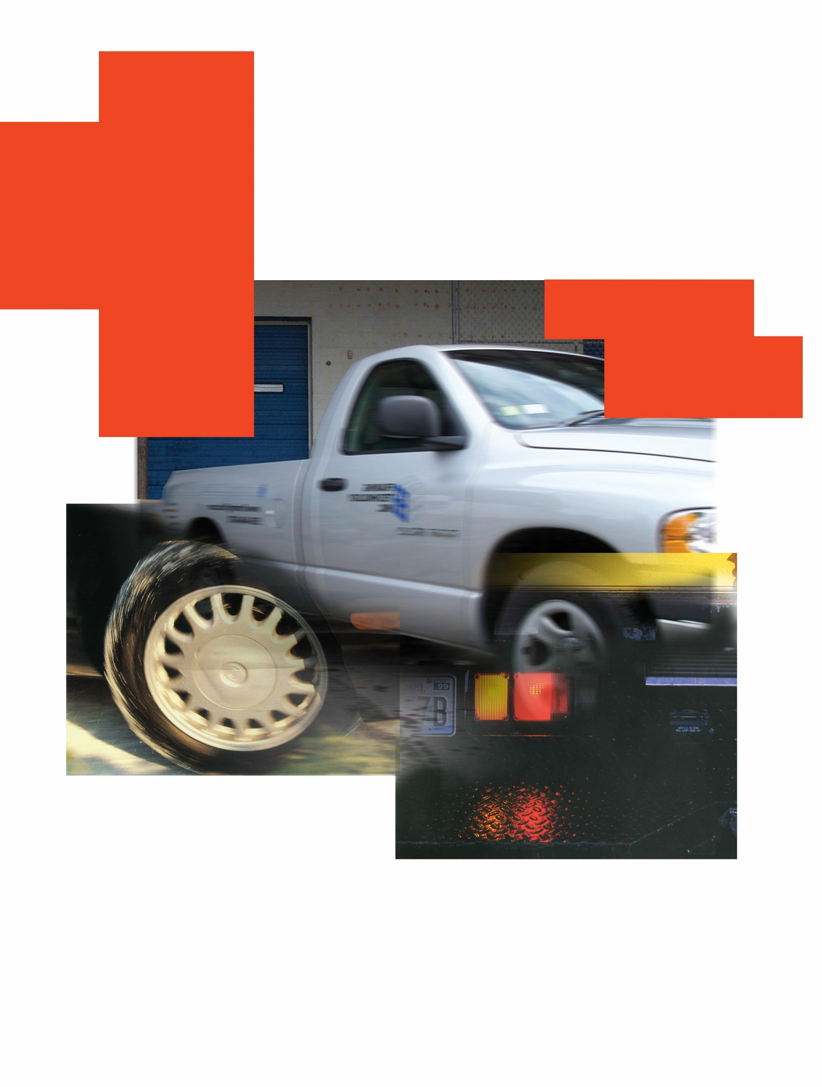

1

“Sample” Fleet Safety Program

For Non-CDL Fleets

Put your County logo here

FLEET SAFETY PROGRAM

Sample Fleet Safety Program for Non-CDL Fleets
This policy is designed for:

Fleets of passenger vehicles and light/medium trucks/vans up to 26,001 GVW or those required to be placarded for Haz-Mat. but includes those transporting 16 or more passengers (including the driver).

“Commercial Motor Vehicle Fleets” as defined by the Federal Motor Carrier Safety Regulations (FMCSR’s) may benefit from chosen sections of this example when used in concert with the FMCSR’s.

Note from CTSI:

This sample fleet safety program is intended to provide you with general information to consider in creating your own fleet safety program. This sample program is not represented to (i) identify all components of a comprehensive fleet safety program, or (ii) comply with any state or federal legal requirements and/or standards. You should adopt no fleet safety program unless it is first reviewed and approved by your attorney and County Commissioners.

Contents:
Management Safety Policy Statement 5
Driver Qualifications/Hiring Criteria 6
Road Tests 8
Cargo Security 9
Experienced Driver, Ongoing Training 10
Drug and Alcohol Policy 10
Accident Involvement and Reporting 11
Emergency Equipment/Accident Kits with Cameras 13
Unauthorized Riders and Drivers 14
Vehicle Restraint Systems (Seatbelts) 14
Vehicle Inspections 15
Vehicle Maintenance 16
Authorized Personal use of County Vehicles 17
Use of Personal Vehicles for County Business 17
County Vehicles and Cell Phones 18
Accident Review Committee 19
Employee Statement of Understanding (Sign-off) 20
Appendix A- (MVR)Motor Vehicle Report Disclosure 21
Appendix B- Road Test 22
Appendix C-“Commercial Vehicle” Post-Trip Insp. 23
Appendix D- Passenger Vehicle Pre-Trip Inspection 24
Notes 25

Sample Management Safety Policy Statement

_________ County Statement of Fleet Safety Policy
Accidents, whether they occur on the streets and highways or on our County property profit no one. They may result in damage to the goods and products in our care. They contribute toward delays in service to our valued customers. When personal injuries occur to our employees, they can cause unnecessary misery as well as possible loss of income.

It is well recognized that most accidents can be prevented, thus avoiding their many undesirable consequences. It is equally well recognized that accident-free operations are not achieved by chance. Rather, they result from the thoughtful application of sound safety principles. To achieve the highest degree of safety, it is our policy, that sound safety principles shall be followed in all of our activities.

To implement our safety policy, an accident control program has been developed and implemented. It applies to all activities at our County and to the operation of our vehicles or operation of personal vehicles when used for County business. It will be conducted through the regular channels of supervision. The accident control program requires the fullest attention and cooperation of all employees.

In short, our policy is to provide service with safety and maximize the efficient use of the public monies we are entrusted with.

(County Commissioner)

(County Commissioner)

(County Commissioners)

Driver Qualifications/Hiring Criteria:

Driver Records

When employment begins with _________ County, to the extent allowed by law, you will be asked to provide, or we will obtain a written history of your previous record of violations and accident experience as recorded from the state Department of Motor Vehicles records. Spouses eligible to drive County vehicles will also have their driving records checked after they have signed-off on the request. The request form that is required to obtain your and/or your spouse’s driving record is noted in Appendix A.

This history will become part of your permanent employee record file. The record was reviewed with you prior to hire. With rare exception, _________ County’s driving record evaluation criteria is as follows.

(Sample) CTSI Recommended

Motor Vehicle Driving Record Evaluation Guide

An individual driver is considered unacceptable (unless there are reasonable extenuating circumstances) if his/her driving record for the most recent three-year period exceeds the following standards:

Driver Ages # of Convictions/Accidents

Age 16 - 20 No convictions No accidents

Age 21 - 24 One conviction
No at-fault accidents

Age 25 – (?) Two convictions and one at-fault accident

or
Three convictions

Single major violations are normally not acceptable and include the following:
- In physical control while under the influence of alcohol or other mind-altering substances
- Homicide or assault with a motor vehicle
- Leaving the scene of an accident
- License revocation/suspension; operating a vehicle while license is suspended
- Reckless driving

- Acceleration or speed contest
- Negligent driving
- Permitting an unlicensed person to drive
- Operating a vehicle without owner’s permission
- Using a motor vehicle for the commission of a felony

_________ County realizes that your driving habits will be no different whether operating County owned equipment or personal vehicles on County business. Therefore, as part of your overall annual job performance review, we will request, at our/your expense, updated information by obtaining current information as supplied from the Department of Motor Vehicles and Licensing. You will be requested to approve the release of an updated driver report based on State requirements.

If new information is negative in nature and exceeds our evaluation criteria, a meeting will be arranged between you and your supervisor. Options at such a point include transfer to a non-driving position, prescription of an advanced driver training course or termination of employment.

Driving records obtained will be kept Confidential.

Road Tests
Prior to operating a County vehicle, in addition to providing a valid driver’s license and meeting the motor-vehicle record criteria, drivers may complete a Road Test provided by an authorized member of management. This is generally a 20-30-minute observation of your driving skills with documentation with the vehicle you are expected to be operating. Undue concerns may result in an advanced driver training course (classroom or over the internet) being required prior to driving a county vehicle.

The Road Test format used is provided in Appendix B.

Cargo Security and Related Driver Distractions

Cargo/Equipment falling from vehicles can result in fatalities to pedestrians or other drivers. Prior to each trip in a County pick-up, truck, or van, a final walk-around of the vehicle “by the driver” should be completed to ensure that all cargo and equipment is adequately secured. Many smaller items as possible should be placed in remotely located vehicle trunks. In cases of questionable security, management or veteran drivers should be contacted for advice.

In the event that cargo nets are supplied by the vehicle manufacturer they should be used to secure movement of items in open passenger compartments.

Seatbelts should be used to secure larger items on the seat including boxes and totes. Smaller items should be placed on the vehicles floor. Zippered bags should be kept closed to minimize the opportunity of content spillage in case of emergent braking.

Experienced Driver Ongoing Training

In support of _________ County’s preventing employee injury, preventing damage to _________ vehicles and protecting our customers and the public,
_________ prescribes periodic (every 3-5 years) experienced driver training.

Drivers of _________ County vehicles or those frequently driving their personal vehicles on _________ business will be requested to take a defensive driver training program within the first XX days of employment. Programs can be internet-based and can be completed on an employee’s home computer or a computer as scheduled by management. Contact your _________ Supervisor/Manager to arrange for completion of this training.

Drugs and Alcohol
_________ County supports the principles of a drug and alcohol-free work place in order to ensure the safety and welfare of the public and our employees. At no time shall a County vehicle or any mobile equipment be operated while a county driver or operator is under the influence of drugs or alcohol. The following are specific restrictions:

- Consumption of an intoxicating beverage within 4 hours of operating a County vehicle or operating a personal vehicle on County business

- The consumption or possession of an intoxicating beverage or controlled substance while (i) on duty, (ii) operating or in physical control of any County vehicle or (iii) on County business in a non-County vehicle.

- Operating any vehicle, or being in physical control of such vehicle, on county business while under the influence of mind altering substances (prescription medication, over the counter medication, hallucinogenic, etc.).

If you test positive for alcohol, mind altering and/or controlled substances or are found to be in possession of such, as outlined above, you will be subject to disciplinary action up to and including termination of employment.

(Employee Signature)

Note: Agreement to the above county policy and agreement to cooperate with post-accident drug test requests of _________ County management.

(Date)

Accident Involvement and Reporting

Any Accident

We require (and following the Federal Motor Carrier Safety Regulations) that whenever an accident results in injury or death to any person or property damage of any kind, regardless of amount, the driver of a motor vehicle (when it is a county vehicle or when you are operating a non-county vehicle in the course of your employment) must:

- Stop without delay! Pull off the road, if possible. Position the vehicle to minimize any obstruction to traffic and set the parking brake. In a serious accident, wait for law enforcement personnel before moving the vehicle.

- Activate the four-way flashers.

- If in imminent danger to loss of life (such as fire or smoke being present or if on an active railroad track), evacuate vehicle occupants to a safe location by utilizing recognized first aid techniques (if known) such as the “clothes drag” or “blanket drag”, recognized/taught by the American Red Cross. Otherwise, do not move occupants.

- Summon aid for those injured (911 in most areas).

- Set up the reflective warning triangles. Placement of the reflective triangles may be delayed for up to ten minutes to attend to life threatening emergencies.

- Provide comfort and solace as the incident requires, make no statements relating to fault or responsibility for the accident.

- Notify law enforcement and your county supervisor. Keep discussions with law enforcement and others to a minimum. Restrain the desire to discuss the accident with anyone other than your county representative.

- Exchange information with others involved in the accident. Acquire the names, addresses, phone numbers, makes of vehicles and license numbers of all drivers, passengers and witnesses. Obtain badge number of police officer. Complete accident report form.

- While maintaining a safe distance from traffic and emergency crews, photograph the damage to all vehicles and/or property. Photograph the relationship of the debris fields and skid marks to the vehicles. Photograph the license plates of all vehicles, including those of witnesses.

Even in instances when the driver strikes a parked vehicle that is unattended, the driver is required to:

- Stop immediately

- Try to locate the owner or custodian of the unattended vehicle.

- If the owner or person responsible for the vehicle cannot be located, the driver must place his/her name and address in a conspicuous place on the vehicle.

- Report all details of the accident to your supervisor as soon as possible.

An Accident Reporting Kit should be placed in the glove compartment of all county vehicles. The camera with this kit should be used to document the damage as noted in 9 above or use a photo capable cell phone.

Emergency Equipment/Accident Kits with Cameras
The following equipment will be provided in all county vehicles:

- A Fire Extinguisher having a UL rating of 5 B:C or more that is mounted to be accessible from the passenger compartment or in the vehicle trunk compartment. This fire extinguisher should be checked monthly and indicated on the tag.
- An emergency blanket
- Reflective triangles to be placed properly at an accident scene
- A disposable camera to photo-document an accident scene or the access to a photo capable cell phone.
- A first aid kit
- A County Accident Report form

It is recommended that employees with extensive driving duties supplement the above with a 72-hour disaster survival kit. These are available from the Red Cross and safety supply distributors.

Unauthorized Riders and Drivers

_________ County does not permit unauthorized drivers or riders in county owned vehicles.

An unauthorized rider or driver shall be defined as: Any person other than the assigned operator of the unit, or a county employee who is un-qualified or not listed on _________ County’s authorized drivers list.

Riders are permitted when they have a business relationship with _________County or the authorized driver of the vehicle.

Vehicle Restraints and Seat Belts

Seat belts are required to be worn by all county vehicle occupants as prescribed by Colorado state statute. It is the responsibility of the driver to ensure that before vehicle is placed in motion that all occupants are securely belted in.

Authorized car seats and booster seats will be used according to Colorado State statute in accordance with appropriate age and size of youth transported.

Any County employee receiving work related injuries as a failure to abide by _________ County Vehicle Restraint and Seat Belt Policy will have their Workers Compensation reduced by 50% as allowed by Colorado statute.

Vehicle Inspections

All county vehicles are to have daily pre-trip inspection performed and documented by the operator. This should include documentation on maintenance concerns that would be seen by the next driver of the vehicle so the vehicle remains safe to operate. A sample pre-trip checklist is noted in Appendix C.

All passenger vehicles are required to have a minimum of annual inspections to ensure proper preventative maintenance (tire rotations, oil changes, etc.), drivability, care and record-keeping. A sample passenger car inspection form is provided in Appendix D. This form can be used for light pickup trucks.

Vehicle Maintenance

Drivers of county vehicles are required to properly maintain the vehicles at all times. Vehicles should not be operated with any defect that would inhibit safe operation during current and foreseeable weather and lighting conditions. Preventive maintenance such as tire rotations, regular oil changes, lubrication and tire pressure and fluid checks, etc. determine to a large extent whether you will have a reliable, safe vehicle to operate and support your work activities.
Preventive maintenance should be completed on your county vehicle as required in the owner’s manual. This service should be done at any one of the authorized dealer listed below or by the county’s Fleet Maintenance Department.
CTSI Optional
The invoice for preventive services should be submitted with your expense accounts if using the Authorized Repair Dealers.
Non-preventative vehicle repairs or service in excess of $100 must have prior approval by .

Authorized Repair Dealer(s):

Use of Personal Vehicles for County Business

When employee-owned vehicles are used for county business purposes, the following procedures will be followed:

- Annual safety checks on the vehicle must be performed. A copy of this safety check should be kept in either the applicable employees file or the Fleet Supervisor’s file.

- Annual confirmation of insurance. Generally, this will be done by checking to make sure that an up-to-date insurance card is in the vehicle as is required in Colorado during the annual safety check.

In cases where a county employee’s duties require them to drive their own vehicle on county business the employee should be asked to provide a copy of their insurance declaration page. The employee may be requested to have the following minimum limits on their personal auto policy:

CTSI Optional but require at least the Colorado State minimum coverage.

- $300,000 combined single limit; or
- $100,000 per person/$300,000 per accident/$50,000 property damage

CTSI Notes:

Minimum limits of personal autos listed above are for business purposes only. They are not meant to address employee’s entire insurance needs. Evaluation of such needs should be referred to the employee’s insurance agent or company.

County Vehicles and Cell Phones

_________ County Distracted Driving Policy

Please read the Distracted Driving Policy, sign and return to your supervisor.

In order to increase employee safety and eliminate unnecessary risks behind the wheel, _________ County has enacted a Distracted Driving Policy. _________ County is committed to ending the epidemic of vehicle crashes caused by distracted driving and have created the following rules which apply to any employee operating a county vehicle; using a county-issued cell phone while operating their personal vehicle or when conducting county business when operating their personal vehicle:

- County employees may not use a hand-held cell phone while operating a vehicle – whether the vehicle is in motion or stopped at a traffic light. This includes, but is not limited to, answering or making phone calls, engaging in phone conversations, and reading or responding to emails, instant messages, and text messages.

- If county employees need to use their phones, they must pull over safely to the side of the road or another safe location.

- Additionally, county employees are required to:
  - Turn cell phones off or put them on silent or vibrate before starting the vehicle.
  - Consider modifying voice mail greetings to indicate that you are unavailable to answer calls or return messages while driving.
  - Inform clients and associates of this policy as an explanation of why calls may not be returned immediately.

- Failing to comply this no cell phone use while driving policy will result in disciplinary action.

I acknowledge that I have received a written copy of the _________County Distracted Driving Policy, that I fully understand the terms of this policy, that I agree to abide by these terms, and that I am willing to accept the consequences of failing to follow the policy.

_________________________________________ ______________________
Employee Signature Date

_________________________________________
Employee Name (printed)

Accident Review Committee

The purpose of this Committee is to review the circumstances involving your accident to determine if the accident was preventable or non-preventable. The National Safety Council guidelines will be used for this determination. A preventable accident is defined by The National Safety Council as:

"Any occurrence involving a vehicle which results in property damage and/or personal injury, regardless of who was injured, what property was damaged, to what extent, or where it occurred; in which the driver in question failed to do everything he/she reasonably could have done to prevent the occurrence.”

The definition of a preventable accident will be strictly and impartially applied. All accidents will be reviewed for evidence of defensive driving techniques in mind.

Note: Accident reviews subsequent to accidents that result in bodily injury and/or legal action may be delayed by _________County management until such action is concluded.

Accident Review Findings

The findings of the accident review Committee will be personally presented to the driver. If the Committee finds the accident preventable and the driver disagrees, they are encouraged to present "their side" and ask for a re-opening of the finding.

The findings of the committee will be placed in the driver’s personal driving file for future review. If the accident was preventable, the driver may be subject to additional action as deemed appropriate by their supervisor or Elected Official. These actions may include, but not be limited to the following:

- Attendance at an advanced driver training seminar
- Assignment (usually temporary) to a non-driving position
- 1 and 2 above
- Termination of employment (when driving record criteria is surpassed)

Employee/Driver Statement of Understanding

ACKNOWLEDGEMENT & CONSENT AGREEMENT
I have read (or have had read to me) and understand the contents of the _________ County Fleet Safety Policy and agree to comply with all requirements. I have been given an opportunity to ask questions and fully understand the meaning of the policies. Additionally, I understand that I should contact my county supervisor should I have any future questions or concerns. By signing below, I acknowledge having receipt of or access to a copy of this policy and consent to agree and abide by the contents.
By signing below, I further acknowledge that failure on my part to comply with any of the policies may result in disciplinary action up to and including termination of employment.

Name (printed) Signature Today’s date

Appendix A

CTSI Note to County Management: There are strict Federal and State laws and regulations regarding obtaining, using and sharing employment and non-employment driving records. You should obtain, use and share no driving records without first seeking the advice of your attorney and other business advisors.

MOTOR VEHICLE REPORT DISCLOSURE

As a condition of my employment at _________ County I authorize you to check my employment and non-employment related driving record. I unconditionally release you from any and all liability relating to furnishing this information.

Name as it appears on License:

Signature:

My Driver’s License Number is:

State of Licensing:

Date of Birth:

Appendix B

ROAD TEST
Non-Commercial Motor Vehicle

Driver Name Date Location Position

Percent Rating
Drives with confidence? ______________
EXPLAIN CIRCUMSTANCES OF CIRCLED ANSWERS ON REVERSE SIDE
 | Check
 | Yes | No | N/A
1. Looks behind and signals before pulling into traffic.
2. Drives in right lane except when passing unless right lane is the lane of least exposure.
3. Maintains safe stopping distance in front of their vehicle (15 – 20 ft. when stopped).
4. Signals turns and passing movements well in advance of turn.
5. Pulls gradually into proper lane well in advance of turn.
6. Approaches green traffic lights prepared to stop for signal change.
7. Strictly obeys all traffic signs, signals and road markings.
8. Yields right-of-way whenever there is any question.
9. Maintains steady speed on open straight aways.
10. Varies speed to meet conditions safely, especially when approaching schools, curves and blind intersections.
11. Applies brakes gradually, avoiding excessive use or sudden stops.
12. Uses good judgment in deciding when to pass.
13. Starts smoothly from standstill – Avoids “jack-rabbit” starts.
14. Keeps car in gear downhill and shifts to low range “if necessary”.
15. Picks safe place to turn around with clear view both ways, turns skillfully.
16. Avoids backing when possible, backs only when knowing everything is clear.
17. Generally keeps both hands on steering wheel, not driving with items in-hand, etc.
18. Alert, reacting quickly to unexpected circumstances.
19. Courteous in yielding to pedestrians and other drivers.
20. Keeps eyes moving, scanning mirrors every 8 – 15 seconds.
21. Turns wheels properly and sets hand brakes when parking on hills.
22. Parks easily and does not hit curb or other vehicles.
23. Follows vehicles in front at safe distance (minimum 3 second following distance).
24. Avoids “creeping” up on vehicles ahead when stopped or going into intersection.

Tested by Date Comments: (Areas of deficiency are to be brought to driver’s attention along with scheduling necessary instruction to correct).

Appendix C

Commercial Vehicle “Daily” Pre/Post-Trip Inspections

Vehicle Inspection Report

Date.......................................... Odometer Reading.............................

Inspection Type:
Pre-Operational Operational Post-Operational

Truck/Tractor No. ...................
- Air Compressor  - Battery  - Body  - Brake Accessories  - Brakes  - Clutch  - Defroster  - Door Handles  - Drive Line  - Emergency Flashers  - Engine  - Fifth Wheel  - Other ................................. | - Front Axle  - Fuel Tanks  - Governor  - Hazardous Materials  - Placarding  - Heater  - Horn  - Inspection Sticker  - Lamps, Reflectors  - Leaks  - Mirrors  - Oil Pressure | - Radiator  - Rear End  - Safety Equipment  - Seat Belts  - Springs  - Steering  - Tachograph  - Tires  - Transmission  - Wheels & Lugs  - Windows, Windshield  - Windshield Wipers

Trailer No. ...............................
(If applicable)

- Brake Connections  - Roof  - Coupling Chains  - Coupling (King) Pin  - Wheels  - Lamps, Reflectors | - Landing Gear  - Cargo Refrigeration -Heater Unit  - Tires (including spare)  - Hazardous Materials Placarding | - Breaks  - Springs  - Tarpaulin  - Doors  - Hitch
- Other (describe) ....................................................................................

Condition of the above vehicles is Satisfactory*
Remarks: ...................................................................................................................................................
.......................................................................................................................................................
.......................................................................................................................................................
.......................................................................................................................................................

* If not Satisfactory, a copy of this report should be kept in the vehicle where very visible to the next driver.

Driver Signature Mechanic Signature

Appendix D Passenger Car Inspection
Driver’s Name | Branch | Job Title
................................................................................................ | ............................. | ................................................................
Unit No. Serial No. License No. | Year Make | Model Mileage To Date
.............................. .............................. ............................. ............ ............ .............................. .............................
General Appearance Good Fair Rough

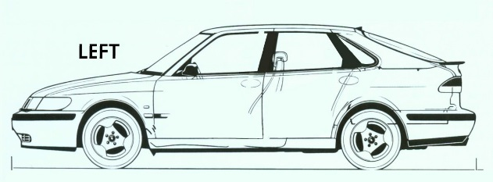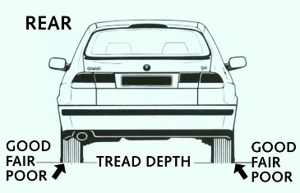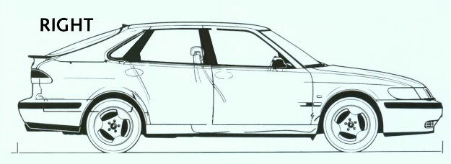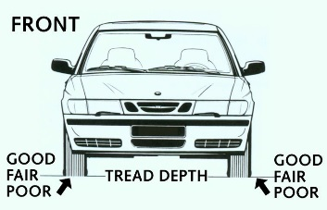

Safety Inspection Maintenance Inspection

Tires (indicate above) OK D Other Equipment
OK D
OK D
Lubrication & Oil

Spare Windshield Wipers Mileage last oil change
Mileage Last Rotation Windshield Washers ........................
........................ Mirrors (condition) Oil level
Lights Horn Condition of oil
Head Lights (low beam) Brakes
(high beam) Hand Brake Leakage of water, fuel Parking Lights Seat Belts (condition) or lubricants under
Yes No
Emer. Flasher Switch (warning device) Vehicle? Tail Lights Ign. Warning Device
OK D
Back-up Lights Trans. Fluid Level
Brake Lights General
Directional Signals Belts, Serpentine
Side & Rear Markers Owner’s Manual Power Steering
Windshield & Glass Battery posts-corrosion
Windshield (above) Radiator Level
Side Shock Absorbers
Rear Heater – Defroster
Air Conditioner

Interior Condition
Floor Mats Carpet Condition Front Seats Rear Seats
Door Panels Head Liner
Mechanical Condition
Engine Noise Braking
Steering, alignment Transmission Overall Performance
Gauges (operational)
List Mechanical Defects
...........................................................
...........................................................
...........................................................
...........................................................
...........................................................
...........................................................
Inspected by Job Title Date
.......................................................... ........................................................... ...........................................................

NOTES:

